Grade Link Information System

**Due date: 06/22/2023**

# OVERVIEW

Student Information System is a software application designed to streamline and manage various aspects of student information and academic records within educational institutions. It serves as a comprehensive platform that integrates administrative, academic, and communication functionalities, allowing schools and educational organizations to efficiently handle student data and facilitate communication between students, parents, teachers, and administrators.

# Application Requirement

Implement the following features:

1. **Student Data Management:** The system allows administrators to maintain detailed student profiles, including personal information.
2. **Grades and Transcripts:** Enables teachers to enter and manage student grades, calculate GPA (Grade Point Average), and generate report cards. It also facilitates the generation of student transcripts, which provide a comprehensive overview of academic performance and achievements.

# Optional:

**Add Student:** The system may add a new student to the school records where you will need to enter their name, grades and their address. This student will be available for access once it has been added to the school records.

# SPECIFICATIONS

Application must be used through the console and present the options available to the user. They may be able to add students to the class, which will save grades and personal information. Here is an example of how a function would be defined in the project:

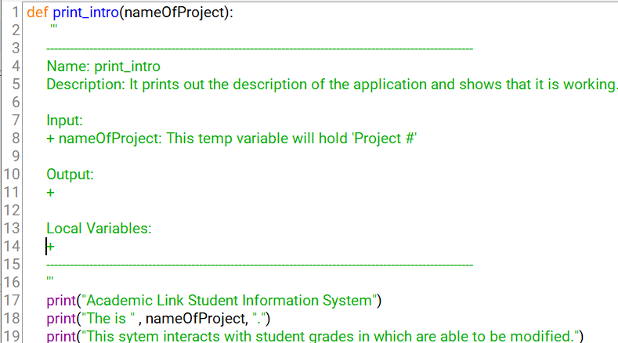

It includes the documentation style as well and each function must be documented as shown to receive full credit. Some will require you to return a data type at the end of a definition. There must be a dictionary that holds the student name as key and the rest of their information as a value.

The following functions are required:

**def find_student( ) - This Function you will need to pass a parameter where it will help you locate the student and their information. Then you will return the students information.**

**def main( ) - This is our main function where the rest of the code will be placed to run the project. Here is where you can create your dictionary, list, or any data type needed for your project.**

**def update_address( ) - This function will update the address of the student you are currently working with. Returns the address that you wanted to update with.**

**def get_grades( ) - Returns the student grades in a report. Will need to access them from the dictionary.**

**def remove_student( ) - Here you will have a student selected, and will delete them from the school records.**

You may create more helper functions if needed. Once the User enters 0 then the application will quit.

Expected Output:

